PRIORITY 1 - #6
FIRST CLEAN UP YOUR ACT!

Introduction:
- The English Dictionary is constantly being updated, eg
  - ‘Homophobia’ was not in dictionary prior to 1995
    - Refers to feelings of antipathy, contempt, prejudice, aversion, irrational fear or hatred of gays
  - ‘Xenophobia’ – intense or irrational fear of people from other countries
  - ‘Islamophobia’ – prejudice against, hatred or fear of Muslims
  - ‘Christaphobia’ – irrational fear of, aversion to, or discrimination against Christians or Christianity
- So we make laws and apply pressure through the media to be politically correct…
  - But it eventually exposes hypocrisy
- Jesus’ Day – time of Passover
  - Custom of decorated tombs – white washed
    - Powder sprinkled around tomb and bones in case someone touched the dead
  - To the politically correct of His day, Jesus said: Matthew 23:25-26.
Woe to you, teachers of the law and Pharisees, you hypocrites! You clean the outside of the cup and dish, but inside they are full of greed and self-indulgence.
Blind Pharisee! First clean the inside of the cup and dish, and then the outside also will be clean.’
    - Cleanse the INSIDE FIRST

- Recognise our Need and Let Him In
- Laodicean church:
  - 20 chapels.
  - Founded by Epaphras??
    - He founded the college there
  - Wealthy
    - Major trade route
    - Textile industry
    - Water in aqueduct had healing properties
  - Destroyed by an earthquake
Revelation 3:17-21 You say, “I am rich; I have acquired wealth and do not need a thing.” But you do not realise that you are wretched, pitiful, poor, blind and naked.
  - V17 – realise our state
    - They had deluded themselves
I counsel you to buy from me gold refined in the fire, so you can become rich; and white cloths to wear, so you can cover your shameful nakedness; and salve to put on your eyes, so you can see.
  - V18 – let Jesus cover you
    - Get your resources from Me
Those whom I love I rebuke and discipline. So be earnest and repent.
  - V19 – repent
    - Remember He loves you
Here I am! I stand at the door and knock. If anyone hears my voice and opens the door, I will come in and eat with him, and he with me.
  - How many rooms is Jesus in?
To him who overcomes, I will give the right to sit with Me on My throne, just as I overcame and sat down with my Father on His throne.
  - overcomers / victorious
    - Right / authority to reign
- Inside change requires an inside agent.

- The Kick Start ILLUSTRATION
Let’s suppose that on January 1, I was flying over Caboolture when the plane exploded. My body fell to the ground and I was dead on impact. Before long, a farmer discovered my corpse. There was no pulse, no heartbeat, no breath. My body was cold. Obviously, I was dead. So the farmer dug a grave. But by the time he placed my body in the earth, it was too dark to cover it. Deciding he would finish in the morning, he returned home.
Then Christ came to me and said, “John, you are dead. Your life on earth is over. But I will breathe into you a breath of new life if you promise to do anything I ask and go anywhere I send you.”
My immediate reaction is “No way! That’s unreasonable! That’s slavery!” But then I realized I was not in a good bargaining position, and I quickly came to my senses. I wholeheartedly agreed.
Instantly my lungs, heart and other vital organs began to function again. I came back to life. I was born again! From that point on, no matter what Christ asked me to do or where he asked me to go, I was more than willing. No task was too difficult, no hours too long, no place too dangerous. Nothing was unreasonable. Why? Because I had no claim to my life. I was living on borrowed time, Christ’s time. John died on January 1 in a Caboolture paddock.

Galatians 2:20 “I have been crucified with Christ and I no longer live, but Christ lives in me. The life I live in the body, I live by faith in the Son of God, who loved me and gave himself for me.”
- We have been changed, we are being changed, and we shall be totally changed.

- The Inside Job
What kind of change occurs depends on what we do with our inner person.
When Leonardo da Vinci was working on The Last Supper, he asked a young man named Pietri Bandinelli, who was a chorister in the Milan Cathedral, to sit for the character of Christ. 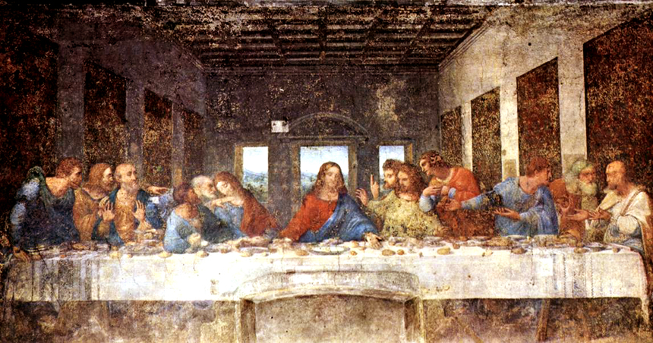
Da Vinci spent the next 25 years working on the painting. He finally had only one character left to paint – Judas Iscariot.
After searching and searching for the right person to sit for the character of Judas, the great artist noticed a man in the streets of Rome, who he asked to be his model. His shoulders were bent toward the ground. He had a cold, hard, evil look on his face. He looked just like da Vinci’s conception of Judas.
When the man was brought into Leonardo da Vinci’s studio, he began to look around as if her were recalling incidents of years gone by. Finally, he turned and with a look of sad discovery said, “Maestro, I was in this studio 25 years ago. I then sat for Christ.”

- Gideon Illustration – disappointed in God
  - Afraid
    - Repented – began to let God in
Judges 6:34 “Then the Spirit of the Lord came upon Gideon, and he blew a trumpet, summoning the [people] to follow him….”

    - God clothed him as a glove
Luke 24:49 I am going to send you what My Father has promised; but stay in the city until you have been clothed with power from on high.
  - Clothed – wrap around

- Walking Free
- Language describes life out of control:
  - All dysfunction is real
    - but this does not mean a ‘life sentence’
John 8:31-32 ‘’to the Jews who had believed him, Jesus said, ‘If you hold to my teaching, you are really my disciples. Then you will know the truth, and the truth will set you free.”
  - Hold to My teaching
    - Then you know who you belong to
  - Truth is – In Christ – new life, new roots that can become a brand new person
1 Peter 1:23 ‘for you have been born again, not of perishable seed, but of imperishable, through the living and enduring word of God.
    - Seed / tree illustration
    - Everything is in the seed, to produce after its kind.
  - Truth is – I can walk in faith
Romans 10:17 – ‘Faith comes by hearing the Word of God’
  - Truth is – I can choose to obey God
Galatians 5:16 – ‘Live by the Spirit, and you will not gratify the desires of the sinful nature.’

Conclusion:
ILLUSTRATION:
She was an embittered woman, Charlotte Elliott of Brighton, England. Her health was broken, and her disability had hardened her. “If God loved me,” she muttered, “He would not have treated me this way.”
Hoping to help her, a Swiss minister named Dr Cesar Malan visited the Elliotts on May 9, 1822. Over dinner, Charlotte lost her temper and railed against God and family in violent outburst. Her embarrassed family left the room, and Dr Malan, alone with her, stared at her across the table.
“You are tired of yourself, aren’t you?” he said at length. “You are holding to your hate and anger because you have nothing else in the world to cling to. Consequently, you have become sour, bitter and resentful.”
“what is your cure?” asked Charlotte.
“The faith you are trying to despise.”
As they talked, Charlotte softened. “If I wanted to become a Christian, and to share the peace and joy you possess,” she finally asked, “what would I do?”
“You would give yourself to God just as you are now, with your fightings, fears, hates and loves, pride and shame.”
“I would come to God just as I am? Is that right?”
Charlotte did come just as she was. Her heart was changed that day. As time passed, she found and claimed John 6:37 as a special verse for her: ‘the one who comes to Me I will by no means cast out.”
Several years later, her brother, Rev Henry Elliott, was raising funds for a school for the children of poor clergymen. Charlotte wrote a poem, and it was printed and sold across England. The Leaflet said: ‘Sold for the benefit of St Margaret’s Hall Brighton: Him that cometh to me I will in no wise cast out.” Underneath was charlottes poem – which has since become the most famous invitational hymn in history:
Just as I am, without one plea,
But that Thy blood was shed for me
And that Thou bidd’st me come to Thee
O Lamb of God, I come! I come!

