PRIORITY 1
#9 – Love for the Church
Introduction: Life is busy!
- Time is our most precious commodity
- The way we handle time affects our values
- VALUE: - something that is esteemed and thought to be of worth
- ACC stats:
  - 2012 – grew by 8%
  - 2018 – grew by 2%
- Qld / NT stats:
  - New church planted every 5 weeks
  - Yet Aust wide, church attendance is declining.
ILLUSTRATION: Letter to Pastor P145 TPSA
Dear Pastor
You often stress attendance at worship as being very important for a Christian, but I think a person has a right to miss now and then. I think every person ought to be excused for the following reasons and the number of times indicated:

- Christmas (Sunday before or after)-1
- End of Summer School Holidays (one last fling)-1
- Easter (get away for holidays)-1
- Long Weekends (National holidays) -2
- Mother’s Day (time with my mother) – 1
- Father’s Day (time with my father) – 1
- End of School Year (Children need a break) – 1
- Family reunions (mine and my wife’s families) – 3
- Sleep-in (Saturday night activities) – 4
- Death in the family – 4
- Anniversary (Second honeymoon) – 1
- Sickness (one for each family member) – 5
- Business trips (can’t be helped) – 4
- Vacations – 4
- Children’s Sports - 5
- Bad weather (too hot, too wet, too cold) – 4
- Unexpected company (can’t walk out) – 5
- Specials on TV (AFL grand final; Bathurst etc) – 3

Pastor, that only leaves two Sundays per year. So you can count on us to be in church on the fourth Sunday in February, and the third Sunday in August, all things going well.

Sincerely yours
Faithful Member.
- What better way to manage our time, than to give the first day of the week for the Lord!
- Church is a Priority
- “Church” primary meaning:
  - Called out ones; assembly
  - Building is secondary
- Early church:
Acts 2:46-47 Every day they continued to meet together in the temple courts. They broke bread in their homes and ate together with glad and sincere hearts, praising God and enjoying the favour of all the people. And the Lord added to their number daily those who were being saved.
Hebrews 10:25 ‘Let us not give up meeting together, as some are in the habit of doing, but let us encourage one another – all the more as you see the Day approaching.’
“…and on the day called Sunday, all who live in cities or in the country gather together in one place, and the memoirs of the apostles or the writings of the prophets are read… But Sunday is the day on which we all hold a common assembly, because it is the first day of the week on which God… made the world; and Jesus Christ our Saviour on the same day rose from the dead.” – Justin Martyr (first Christian philosopher who lived AD100-165)
- David’s story: David was on the run from Saul
  - Doeg the Edomite dobs David in to Saul
  - David will be pressured on all sides
Psalm 52:8-9 ‘But I am like an olive tree flourishing in the house of God; I trust in God’s unfailing love forever and ever. I will praise you forever for what you have done; in your name I will hope, for your name is good. I will praise you in the presence of your saints.’

- Church is a Gateway
- Jacob’s story – the dream
Genesis 28:12 He had a dream in which he saw a stairway resting on the earth, with its top reaching to heaven, and the angels of God were ascending and descending on it.
- Jacob’s story – the promise
Genesis 28:13-15 …there above it stood the Lord, and He said: “I am the Lord, the God of your father Abraham and the God of Isaac. I will give you and your descendants the land on which you are lying. Your descendants will be like the dust of the earth, and you will spread out to the west and to the east, to the north and to the south. All peoples on earth will be blessed through you and your offspring. I am with you and will watch over you wherever you go, and I will bring you back to this land; I will not leave you until I have done what I have promised to you.
Genesis 28:16-17 When Jacob woke from his sleep, he thought, “surely the Lord is in this place, and I was not aware of it.”
- The Lord was in the place
He was afraid, and said, ‘How awesome is this place! This is none other than the house of God; this is the gate of heaven.’
- The house of God / Gate of heaven
  - First time this phrase used in Scripture
  - House of God = gate of heaven
- When Jesus was baptised ‘saw heaven opened’
  - Group setting
- At Pentecost, heaven opened.
- Jesus is ‘head of the church’
Ephesians 3:10 ‘His intent that now, through the church, the manifold wisdom of God should be made known to the rulers and authorities in the heavenly realms.’
  - His intent – through the church
    - Manifold wisdom – many sided, infinite variety, immeasurable aspects
    - Make plain what God is doing

- Church Motivated by Love
- Our Priority
Matthew 22:37-39 Jesus replied: “Love the Lord your God with all your heart and with all your soul and with all your mind.” This is the first and greatest commandment. And the second is like it:
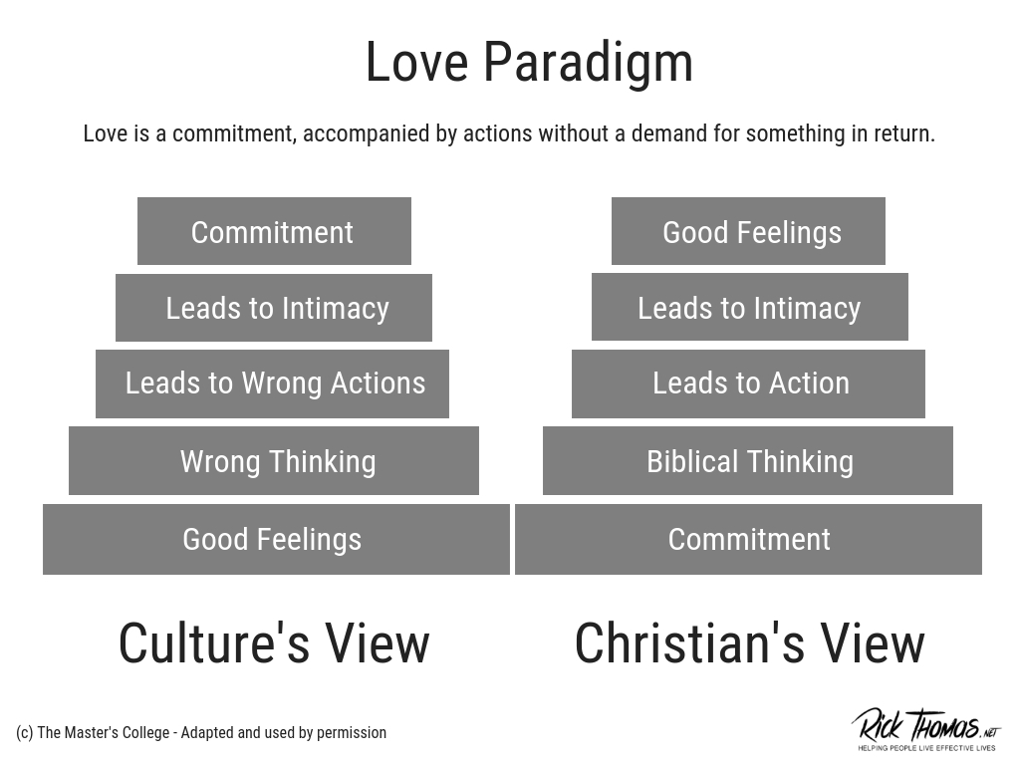

- Love with your mind
- What do I think about the church?
Proverbs 18:17 The first to present his case seems right, till another comes forward and questions him.
1 Corinthians 13:6-7 ‘Love does not delight in evil but rejoices in the truth. It always protects, always trusts, always hopes, always perseveres.
- Truth, not here-say
- Protect / bear with one another
- Trust / believe
- Hope
- Persevere / endure

- Love with What I Say
Ephesians 4:29 ‘Do not let any unwholesome talk come out of your mouths, but only what is helpful for building others up according to their needs, that it may benefit those who listen..
- Build up one another
- Make music in your heart and be thankful
  - Prophetic singers of Korah
Psalm 49:3-4 ‘My mouth will speak words of wisdom; the utterance from my heart will give understanding. I will turn my ear to a proverb; with the harp I will expound my riddle.’
Declaration:
Ephesians 3:16-21 I pray that out of his glorious riches he may strengthen you with power through His Spirit in your innermost being, so that Christ may dwell in your hearts through faith.
And I pray that you, being rooted and established in love, may have power, together with all the saints, to grasp how wide and long and high and deep is the love of Christ, and to know this love that surpasses knowledge – that you may be filled to the measure of all the fullness of God.
Now to Him who is able to do immeasurably more than all we ask or imagine, according to His power that is at work within us, to Him be glory in the church and in Christ Jesus throughout all generations, for ever and ever! Amen.

