PRIORITY 1
#4 STRONG LOVE

Introduction:
- Seek first the kingdom of God and His righteousness [Matt 6:33]
- First take the plank out of your own eye [Matt 7:5]
  - Don’t try to fix everyone else and ignore yourself
- Strong Love
John 13:34 “A new command I give you: Love one another. As I have loved you, so you must love one another.”

- Unity is More Important than Worship
Matthew 5:23-24 “Therefore, if you are offering your gift at the altar and there remember that your brother has something against you, leave your gift there in front of the altar. First go and be reconciled to your brother; then come and offer your gift.”
- Offering – first fruits, tithes, thanks offering…
- We kid ourselves if we think we are spiritual if there is disunity.
- Jesus said ‘FIRST be reconciled….’
  - Reconcile = make peace
Matthew 5:9 ‘Blessed are the peacemakers, for they will be called the Sons of God.’

- Love’s Outworking
Acts 2:42 ‘They devoted themselves to the apostles’ teaching and to the fellowship, to the breaking of bread and to prayer.’
- The early church’s priority was fellowship
  - koinonia [coin-own-ee-a] – also translated as:
    - sharing,
    - contribution,
    - association,
    - participation

- Kingdom Partnerships
- Someone you partner with to extend the kingdom of God
  - Examples:
    - Paul & Barnabas [Acts 15:36-41]
    - Paul & Peter [Galatians 2:11-12]
    - Euodia & Syntyche
Phiippians 4:2… “be of the same mind in the Lord.”
- Covenant relationships
- Marriage
Ephesians 5:21-22 “Submit to one another out of reverence for Christ. Wives, to your own husbands as you do to the Lord.”
- Supportive….
  - A voluntary attitude
Ephesians 5:25 “Husbands, love your wives, just as Christ loved the church and gave himself up for her.”
- Demonstrate love
- Friendships
- Survive in spite of trials, hurts, misunderstanding
  - ‘a friend is someone who walks in when others walk out’
- Jesus places friendship, relationships, reconciliation and forgiveness higher than the functioning of our gifts, successes and even worship.
John 13:35 “…By this everyone will know that you are my disciples, if you love one another.”
- Let the world know

- The Power of Words
- Inappropriate words often come out of anger
Matthew 5:22 But I tell you that anyone who is [continually] angry with a brother or sister^{[a][b]} will be subject to judgment. Again, anyone who says to a brother or sister, ‘Raca’, is answerable to the court. And anyone who says, ‘You fool!’ will be in danger of the fire of hell.
  - Anger – ‘continues to be angry’
Ephesians 4:26b ‘Do not let the sun go down while you are still angry…’
- Examples:
  - ‘Raca’ = word of contempt; an insult
    - Bring a judgment of your peers
  - Fool = cursed, fallen morally, doomed
    - Bring a judgment on yourself / danger
Ephesians 4:26b “Don’t let the sun go down while you are still angry.”

- Settle Quickly
- Matthew 5:25 – ‘settle matters quickly’
- Offence – an offence is a stumbling block that causes distrust.
Proverbs 18:19 ‘It is easier to conquer a strong city than to win back a friend whom you’ve offended. Their walls go up, making it nearly impossible to win them back. (TPT)
Trespass – sins against, to step over a stated line, or boundary. If a person does not know the other person’s boundaries, or refuses to respect them, deep offences build.
- Key – forgiveness – not holding the other person’s deed against them.

Conclusion:
This is a true story:
Imagine this scene from a recent courtroom trial in South Africa: A frail black woman stands slowly to her feet. She is about 70 years of age. Facing her from across the room are several white police officers, one of whom, Mr. van der Broek, has just been tried and found implicated in the murders of both the woman's son and her husband some years before.

It was indeed Mr. Van der Broek, it has now been established, who had come to the woman's home a number of years back, taken her son, shot him at point-blank range and then burned the young man's body on a fire while he and his officers partied nearby.

Several years later, Van der Broek and his security police colleagues had returned to take away her husband as well. For many months she heard nothing of his whereabouts.

Then, almost two years after her husband's disappearance, Van der Broek came back to fetch the woman herself. How vividly she remembers that evening, going to a place beside a river where she was shown her husband, bound and beaten, but still strong in spirit, lying on a pile of wood. The last words she heard from his lips as the officers poured gasoline over his body and set him aflame were, "Father, forgive them."

And now the woman stands in the courtroom and listens to the confessions offered by Mr. Van der Broek. A member of South Africa's Truth and Reconciliation Commission turns to her and asks, "So, what do you want? How should justice be done to this man who has so brutally destroyed your family?"

"I want three things," begins the old woman, calmly but confidently. "I want first to be taken to the place where my husband's body was burned so that I can gather up the dust and give his remains a decent burial."

She pauses, and then continues. "My husband and son were my only family. I want, secondly, therefore, for Mr. Van der Broek to become my son. I would like for him to come twice a month to the ghetto and spend a day with me so that I can pour out on him whatever love I still have remaining within me."

"And, finally," she says, "I want a third thing. I would like Mr. Van der Broek to know that I offer him my forgiveness because Jesus Christ died to forgive. This was also the wish of my husband. And so, I would kindly ask someone to come to my side and lead me across the courtroom so that I can take Mr. van der Broek in my arms, embrace him and let him know that he is truly forgiven."

As the court assistants come to lead the elderly woman across the room, Mr. van der Broek, overwhelmed by what he has just heard, faints. And as he does, those in the courtroom, friends, family, neighbors — all victims of decades of oppression and injustice — begin to sing, softly, but assuredly, "Amazing grace, how sweet the sound, that saved a wretch like me."
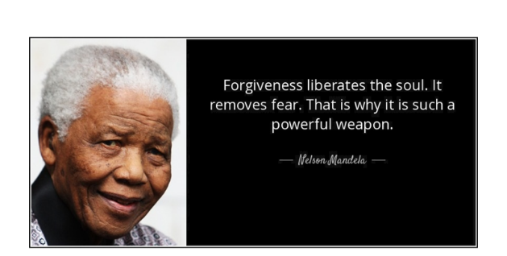
Picture: Nelson Mandela: Forgiveness liberates the soul. It removes fear. That is why it is such a powerful weapon.

